The Annual Quality Assurance Report (AQAR)
of the
IQAC : 2014-15
……………………………………………………………………………………..

Submitted By
Janata Education Society’s
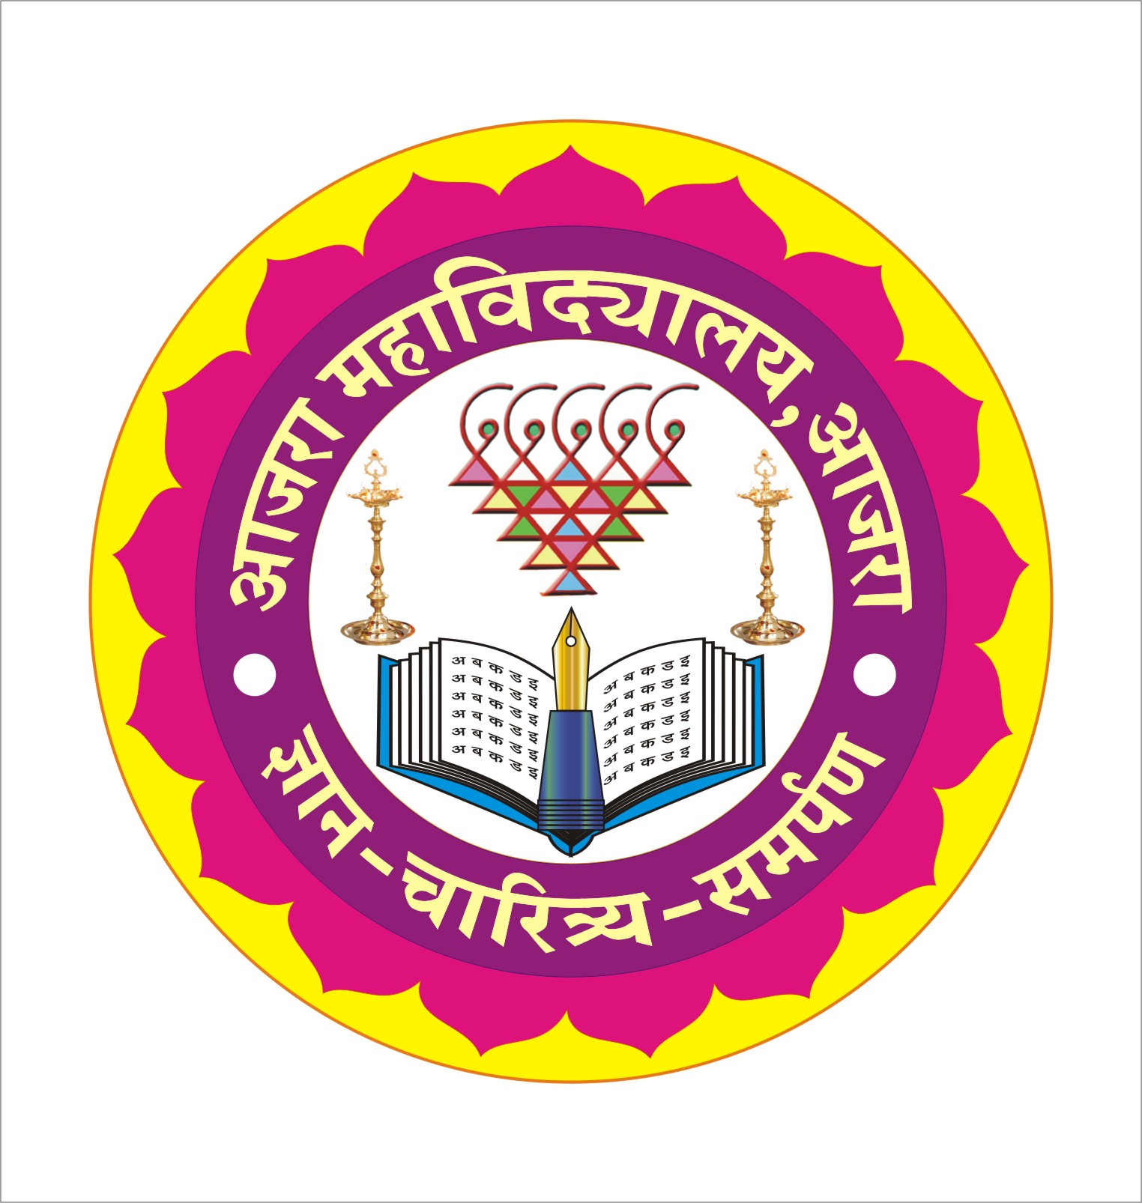
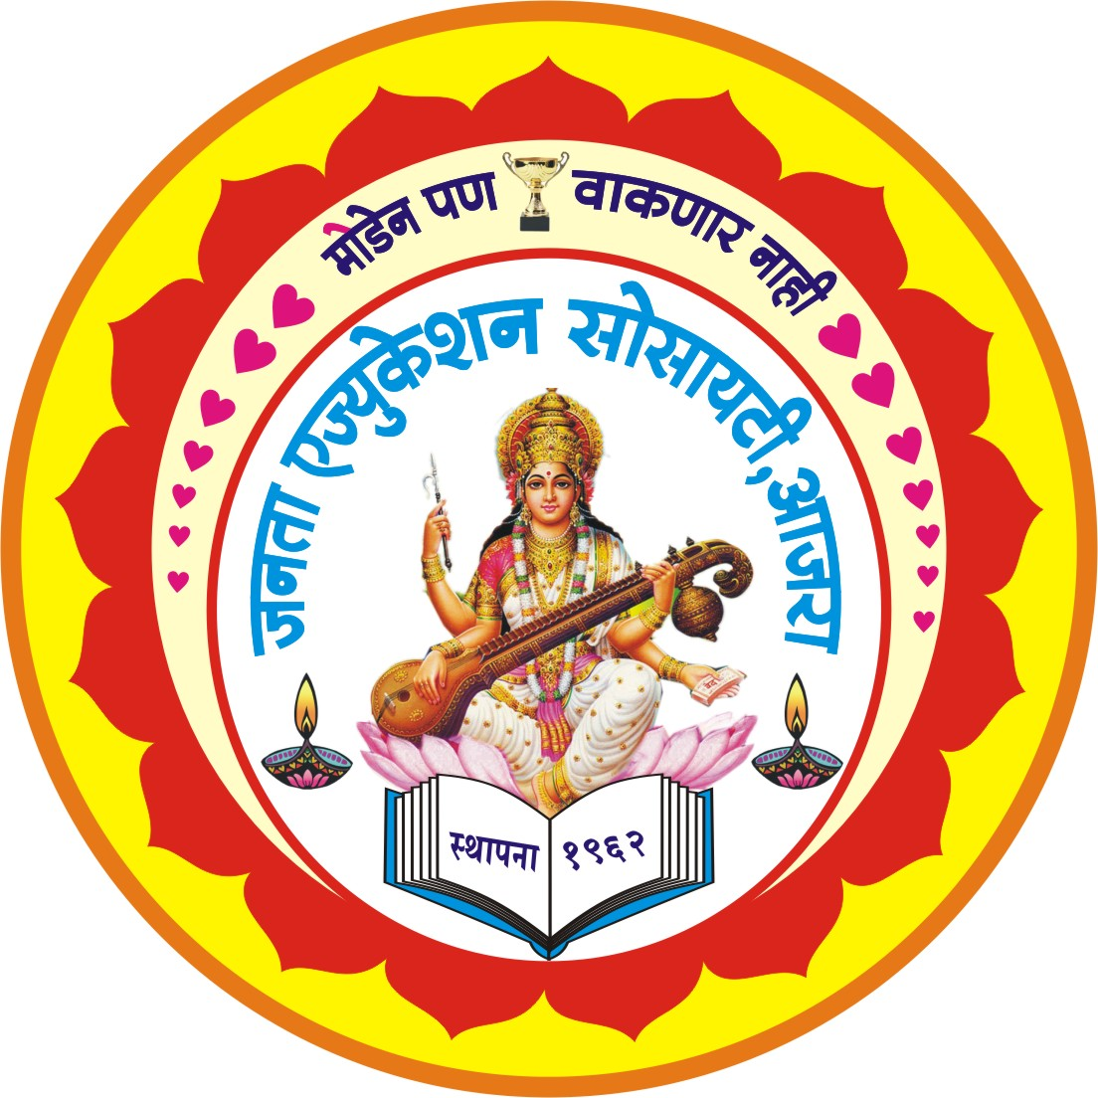
AJARA MAHAVIDYALAYA, AJARA,
Tal.Ajara,Dist.Kolhapur,(Maharashtra)-416505
[Affiliated to Shivaji University,Kolhapur University]
Re-Accredited ‘B’ by NAAC [2.70 CGPA]

……………………………………………………………………………………..

To

NAAC
National Assessment and Accreditation Council,
P.O.Box No.1075,Bangalore-560072
Karnataka, INDIA

September 2015

The Annual Quality Assurance Report (AQAR) of the IQAC

All NAAC accredited institutions will submit an annual self-reviewed progress report to NAAC, through its IQAC. The report is to detail the tangible results achieved in key areas, specifically identified by the institutional IQAC at the beginning of the academic year. The AQAR will detail the results of the perspective plan worked out by the IQAC. (Note: The AQAR period would be the Academic Year. For example, July 1, 2012 to June 30, 2013)

Part – A
1. Details of the Institution
Ajara Mahavidyalaya, Ajara
1.1 Name of the Institution
At/po. Ajara Tal. Ajara
1.2 Address Line 1
Dist. Kolhapur
Address Line 2
Ajara
City/Town
Maharashtra
State
416505
Pin Code
ajaracollege@rediffmail.com
principal@ajaracollege.ac.in
Institution e-mail address
02323-246372
Contact Nos.
Dr. M. L. Hongekar
Name of the Head of the Institution:
02323-246372
Tel. No. with STD Code:
9890026026
Mobile:

Dr. S. B. Bhandare
Name of the IQAC Co-ordinator:
9975098443
Mobile:
Bhandare.sb@rediffmail.com
IQAC e-mail address:
Not Available Reaccreditation done in Oct-2013
1.3 NAAC Track ID (For ex. MHCOGN 18879)

1.4 NAAC Executive Committee No. & Date:
EC/57/RAR/64 dated 30-11-2011
(For Example EC/32/A&A/143 dated 3-5-2004.
This EC no. is available in the right corner- bottom
of your institution’s Accreditation Certificate)

http://www.ajaracollege.ac.in
1.5 Website address:
http://www.ajaracollege.ac.in/links/AMAAQAR2014-15.doc
Web-link of the AQAR:
For ex. http://www.ladykeanecollege.edu.in/AQAR2012-13.doc
1.6 Accreditation Details
Sl. No. | Cycle | Grade | CGPA | Year of Accreditation | Validity Period
1 | 1st Cycle | B+ | NA | 2004 | Jan 08, 2009
2 | 2nd Cycle | B | 2.70 | 2011 | Nov 29, 2016
3 | 3rd Cycle | - | - | - | -
4 | 4th Cycle | - | - | - | -

21/07/2005
1.7 Date of Establishment of IQAC : DD/MM/YYYY

2014-2015
1.8 AQAR for the year (for example 2010-11)

1.9 Details of the previous year’s AQAR submitted to NAAC after the latest Assessment and Accreditation by NAAC ((for example AQAR 2010-11submitted to NAAC on 12-10-2011)
- AQAR 2012-13 Submitted to NAAC on 28/09/2013
- AQAR 2013-14 Submitted to NAAC on 27/09/2014
- AQAR 2014-15 Submitted to NAAC on 28/09/2015
- AQAR__________________ _______________________ (DD/MM/YYYY)
1.10 Institutional Status

University State Central Deemed Private


Affiliated College Yes No
Constituent College Yes No

Autonomous college of UGC Yes No

Regulatory Agency approved Institution Yes No
(eg. AICTE, BCI, MCI, PCI, NCI)


Type of Institution Co-education Men Women



Urban Rural Tribal





Financial Status Grant-in-aid UGC 2(f) UGC 12B

Grant-in-aid + Self Financing Totally Self-financing


1.11 Type of Faculty/Programme


Arts Science Commerce Law PEI (Phys Edu)




TEI (Edu) Engineering Health Science Management

Bachelor of Computer Application (B.CA.)
Others (Specify)
Shivaji University Kolhapur
1.12 Name of the Affiliating University (for the Colleges)

1.13 Special status conferred by Central/ State Government-- UGC/CSIR/DST/DBT/ICMR etc
NA
Autonomy by State/Central Govt. / University

University with Potential for Excellence UGC-CPE

DST Star Scheme UGC-CE

UGC-Special Assistance Programme DST-FIST

UGC-Innovative PG programmes Any other (Specify)

UGC-COP Programmes

2. IQAC Composition and Activities
05
2.1 No. of Teachers
01
2.2 No. of Administrative/Technical staff
02
2.3 No. of students
2.4 No. of Management representatives
02
02
2.5 No. of Alumni
2. 6 No. of any other stakeholder and
01
community representatives
03
2.7 No. of Employers/ Industrialists
00
2.8 No. of other External Experts
2.9 Total No. of members
15
2.10 No. of IQAC meetings held 04
09
04
2.11 No. of meetings with various stakeholders: No. Faculty
02
01
02
Non-Teaching Staff Students Alumni Others
2.12 Has IQAC received any funding from UGC during the year? Yes No
/-



If yes, mention the amount
2.13 Seminars and Conferences (only quality related)
(i) No. of Seminars/Conferences/ Workshops/Symposia organized by the IQAC
02
-
-
-
02
Total Nos. International National State Institution Level
1) Revised AQAR Format – Workshop organized by IQAC
2) Roll of staff Members in IQAC – Workshop addressed by Prof. Pambrekar.
(ii) Themes

2.14 Significant Activities and contributions made by IQAC
The IQAC instructed the staff about the revised self study report of NAAC & advised them to function accordingly. The plan of action was prepared by the IQAC keeping in view the revised methodology of NAAC.

2.15 Plan of Action by IQAC/Outcome
The plan of action chalked out by the IQAC in the beginning of the year towards quality
enhancement and the outcome achieved by the end of the year *

Plan of Action | Achievements
Annexure-I | Annexure-II
* Attach the Academic Calendar of the year as Annexure.


2.16 Whether the AQAR was placed in statutory body Yes No


Management Syndicate Any other body
Provide the details of the action taken
The Management approved the AQAR and asked the IQAC Committee to forward it to NAAC, Bangalore in time

Part – B
Criterion – I
1. Curricular Aspects

1.1 Details about Academic Programmes
Level of the Programme | Number of existing Programmes | Number of programmes added during the year | Number of self-financing programmes | Number of value added / Career Oriented programmes
PhD | - | - | - | -
PG | 02 | - | 02 | -
UG | 04 | - | 01 | -
PG Diploma | - | - | - | -
Advanced Diploma | - | - | - | -
Diploma | - | - | - | -
Certificate | - | - | - | -
Others (Remedial Coaching) | 01  (English) | - | - | -
Total | 07 | - | 03 | -

Interdisciplinary | - | - | - | -
Innovative | - | - | - | -

1.2 (i) Flexibility of the Curriculum: CBCS/Core/Elective option / Open options
(ii) Pattern of programmes:
Pattern | Number of programmes
Semester | 12
Trimester | -
Annual | -

-


-


1.3 Feedback from stakeholders* Alumni Parents Employers Students
(On all aspects)
-


-
Mode of feedback : Online Manual Co-operating schools (for PEI)
*Please provide an analysis of the feedback in the Annexure-III

1.4 Whether there is any revision/update of regulation or syllabi, if yes, mention their salient aspects.
Yes. Syllabus is updated of B.A.II, B.Com.II, B.Sc.II, B.C.A.II, M.A.II, M.Com.II Part-II) by the University.

1.5 Any new Department/Centre introduced during the year. If yes, give details.
NO

Criterion – II
2. Teaching, Learning and Evaluation
2.1 Total No. of permanent faculty
Total | Asst. Professors | Associate Professors | Professors | Others
22 | 15 | 07 | Nil | -
13
2.2 No. of permanent faculty with Ph.D.
2.3 No. of Faculty Positions Recruited (R) and Vacant (V) during the year
Asst. Professors |  | Associate Professors |  | Professors |  | Others |  | Total
R | V | R | V | R | V | R | V | R | V
- | - | - | - | - | - | - | - | - | -
-
02
29
2.4 No. of Guest and Visiting faculty and Temporary faculty

2.5 Faculty participation in conferences and symposia:

No. of Faculty | International level | National level | State level
Attended Seminars/ Workshops | 04 | 30 | 06
Presented papers | 06 | 29 | 05
Resource Persons | - | 03 | 02

2.6 Innovative processes adopted by the institution in Teaching and Learning:
1. Remedial Teaching 2. Skill Oriented Programme
3. Value Add Programme 4. ICT based Teaching Learning

182
2.7 Total No. of actual teaching days
during this academic year
2.8 Examination/ Evaluation Reforms initiated by
Photocopy, Multiple Choice Open Book Exercise, Double valuation
the Institution (for example: Open Book Examination, Bar Coding,
Double Valuation, Photocopy, Online Multiple Choice Questions)
21
3
-
2.9 No. of faculty members involved in curriculum
restructuring/revision/syllabus development
as member of Board of Study/Faculty/Curriculum Development workshop
80%
2.10 Average percentage of attendance of students

2.11 Course / Programme wise distribution of pass percentage :

Title of the Programme | Total no. of students appeared | Division |  |  |  | Pass Percentage
Title of the Programme | Total no. of students appeared | Distinction % | I % | II % | III % | Pass Percentage
B.A. | 77 | 11.68 | 37.66 | 44.15 | 5.19 | 87.50%
B.Com. | 79 | 7.59 | 15.18 | 37.97 | 26.58 | 87.00%
B.Sc. | 109 | 66.97 | 31.19 | 0.91 | Nil | 95.65%
B.C.A. | 10 | 26.66 | 33.33 | 13.33 | Nil | 66.66%

2.12 How does IQAC Contribute/Monitor/Evaluate the Teaching & Learning processes :
Monthly Review meetings & Periodical / Occasional Departmental Meetings.
2.13 Initiatives undertaken towards faculty development
Faculty / Staff Development Programmes | Number of faculty  benefitted
Refresher courses | 03
UGC – Faculty Improvement Programme | -
HRD programmes | -
Orientation programmes | 01
Faculty exchange programme | -
Staff training conducted by the university | 03
Staff training conducted by other institutions | -
Summer / Winter schools, Workshops, etc. | 19
Others (Lead College Activities) | -
2.14 Details of Administrative and Technical staff
Category | Number of Permanent  Employees | Number of Vacant  Positions | Number of permanent positions filled during the Year | Number of positions filled temporarily
Administrative Staff | 27 | 01 | - | -
Technical Staff | - | - | - | -
Criterion – III
3. Research, Consultancy and Extension
3.1 Initiatives of the IQAC in Sensitizing/Promoting Research Climate in the institution
Research cell promotes research activities among teachers, administrative staff & students. Facilities for doing research work were provided to the concerned by the management. Various academic departments were assigned minor research project.

3.2 Details regarding major projects
 | Completed | Ongoing | Sanctioned | Submitted
Number | - | - | - | 01
Outlay in Rs. Lakhs | - | - | - | 10,00,000

3.3 Details regarding minor projects
 | Completed | Ongoing | Sanctioned | Submitted
Number | - | 02 | - | 02
Outlay in Rs. Lakhs | - | 4,25,000/- | - | 8,00,000

3.4 Details on research publications
 | International | National | Others
Peer Review Journals | 08 | 01 | -
Non-Peer Review Journals | 08 | 01 | -
e-Journals | 01 | - | -
Conference proceedings | 03 | 09 | 01

3.5 Details on Impact factor of publications:
0-2
-
2
1
Range Average h-index Nos. in SCOPUS
3.6 Research funds sanctioned and received from various funding agencies, industry and other organisations
Nature of the Project | Duration  Year | Name of the  funding Agency | Total grant  sanctioned | Received
Major projects | - | - | - | -
Minor Projects | 2014-16 | UGC | 4,25,000 | 3,32,000
Interdisciplinary Projects | - | - | - | -
Industry sponsored | - | - | - | -
Projects sponsored by the University/ College | - | - | - | -
Students research projects  (other than compulsory by the University) | - | - | - | -
Any other(Specify) | - | - | - | -
Total | 02 | - | 4,25,000 | 3,32,000

3.7 No. of books published i) With ISBN No. Chapters in Edited Books
4
4
1
ii) Without ISBN No.
3.8 No. of University Departments receiving funds from
NA
UGC-SAP CAS DST-FIST
-
-
-
-
DPE DBT Scheme/funds
3.9 For colleges Autonomy CPE DBT Star Scheme
-
-
-
INSPIRE CE Any Other (specify)
-
-
-
NIL
3.10 Revenue generated through consultancy
Level | International | National | State | University | College
Number | - | - | - | - | 02
Sponsoring agencies | - | ICSSR New Delhi |  |  | Lead College
3.11 No. of conferences
organized by the Institution

04
3.12 No. of faculty served as experts, chairpersons or resource persons.
-
-
-
3.13 No. of collaborations International National Any other
-
3.14 No. of linkages created during this year
3.15 Total budget for research for current year in lakhs: -
3.320/-
-
From funding agency From Management of University/College
Total
3.320/-

3.16 No. of patents received this year
Type of Patent |  | Number
National | Applied | -
National | Granted | -
International | Applied | -
International | Granted | -
Commercialised | Applied | -
Commercialised | Granted | -

3.17 No. of research awards/ recognitions received by faculty and research fellows
Of the institute in the year
Total | International | National | State | University | Dist | College
01 | - | - | - | 01 | - | -

3.18 No. of faculty from the Institution
02
who are Ph. D. Guides
and students registered under them
08

3.19 No. of Ph.D. awarded by faculty from the Institution
-

3.20 No. of Research scholars receiving the Fellowships (Newly enrolled + existing ones)
-
-
JRF SRF Project Fellows Any other
-
-

3.21 No. of students Participated in NSS events:
04
01
University level State level
National level International level
-
-
3.22 No. of students participated in NCC events:
-
13
University level State level
National level International level
8
-
3.23 No. of Awards won in NSS:
-
University level State level
-
National level International level
-
-
3.24 No. of Awards won in NCC:
University level State level
-
-
National level International level
-
-
3.25 No. of Extension activities organized
-
06
University forum College forum
08
15
-
NCC NSS Any other

3.26 Major Activities during the year in the sphere of extension activities and Institutional Social Responsibility
- Blood Donation Camp
- Eradication of Plastic Campagin
- Financial Assistantance to needy persons by staff, faculty & students.

Criterion – IV
4. Infrastructure and Learning Resources
4.1 Details of increase in infrastructure facilities:
Facilities | Existing | Newly created | Source of Fund | Total
Campus area | 4354.94 sq.m. | - | NA | 4354.94 sq.m.
Class rooms | 34 | - | * JES | 34
Laboratories | 08 | 01 | * JES | 09
Seminar Halls | 01 | - | NA | 01
No. of important equipments purchased (≥ 1-0 lakh) during the current year. | - | - | - | -
Value of the equipment purchased during the year (Rs. in Lakhs) | - | - | - | -
Others | - | - | - | -
* JES – Janata Education Society, Ajara

4.2 Computerization of administration and library
Most of the office Administration work is computerized.
Library is fully computerized.

4.3 Library services:
 | Existing |  | Newly added |  | Total
 | No. | Value | No. | Value | No. | Value
Text Books | 12212 | 27,53,633 | 527 | 45559 | 12739 | 28,73,903
Reference Books | 9524 | 27,53,633 | 208 | 74711 | 9732
Journals | 47 | 18514 | 5 | 5140 | 53 | 19744
Journals | 47 | 18514 | 6 | Donated | 53 | 19744
e-Books | 100000 | 5000 | - | - | 100000 | 5000
e-Journals | 3000 | 5000 | - | - | 3000 | 5000
Digital Database | 1 | 5000 | - | - | 1 | 5000
CD & Video | 118 | - | 25 | - | 143 | -
Others (specify) Audio Visual | 51 | 46007 | - | - | 51 | 46007
Picture / Photo | 64 | - | - | - | 64 | -
Book Bank | 624 | 44282 | - | - | - | -
Donated Book | 843 | - | 250 | - | 1093 | -

4.4 Technology up gradation (overall)
 | Total Computers | Computer Labs | Internet | Browsing Centres | Computer Centres | Office | Depart-ments | Others
Existing | 86 | 39 | 56 | 05 | - | 08 | 28 | -
Added | - | - | - | - | - | 01 | - | -
Total | 86 | 39 | 56 | 05 | - | 09 | 28 | -

4.5 Computer, Internet access, training to teachers and students and any other programme for technology
upgradation (Networking, e-Governance etc.)
Skill Oriented Course
Study Forum

4.6 Amount spent on maintenance in lakhs :
0.29
i) ICT
0.10
ii) Campus Infrastructure and facilities
0.51
iii) Equipments
0.37
iv) Others

1.27
Total :

Criterion – V
5. Student Support and Progression
5.1 Contribution of IQAC in enhancing awareness about Student Support Services
The following steps where taken for enhancing awareness
- Facilities available under student support services were informed to students through the college prospectus at the beginning of year
- Instructions were given to the staff in various meetings held throughout the year.
- Instructions were given to concerned departments at the beginning of year.
- Meetings of the students were held to guide about support services of Govt. & College.

5.2 Efforts made by the institution for tracking the progression
- The progress of these activities was considered & evaluated in monthly staff meetings held during the year.
- The institution tracks the progression a) through office b) through faculty.
- The progression of the students is also discussed in the alumni meet.

5.3 (a) Total Number of students
UG | PG | Ph. D. | Others
1003 | 86 | - | -

(b) No. of students outside the state
NIL
NIL
(c) No. of international students

Men Women
No | %
436 | 40.03
No | %
653 | 59.96

Last Year (2013-14)) |  |  |  |  |  | This Year (2014-15)
General | SC | ST | OBC | Physically Challenged | Total | General | SC | ST | OBC | Physically Challenged | Total
951 | 72 | 02 | 112 | - | 1137 | 834 | 67 | 03 | 99 | 04 | 1003
Demand ratio 0.63 Dropout % 0.60

5.4 Details of student support mechanism for coaching for competitive examinations (If any)
- There is an independent Competitive exam guidance center in the college.
- Lectures of eminent resources persons are organized from time to time for the benefit of desirable students.
- The central library provides the necessary books & other reading material to the students.
- Internet facility is provided free of cost to the students.

27
No. of students beneficiaries

5.5 No. of students qualified in these examinations
-
-
-
-
NET SET/SLET GATE CAT
IAS/IPS etc State PSC UPSC Others
-
-
-
-

5.6 Details of student counselling and career guidance
Counseling is provided to the students by the faculty through out the year.
Three lectures organized regarding career guidance.
Displaying career guidance clipping on notice board in library.

100
No. of students benefitted

5.7 Details of campus placement
On campus |  |  | Off Campus
Number of Organizations Visited | Number of Students Participated | Number of Students Placed | Number of Students Placed
01 | 40 | Nil | Nil

5.8 Details of gender sensitization programmes
Four Programs were organized on gender sensitization.

5.9 Students Activities
5.9.1 No. of students participated in Sports, Games and other events
State/ University level National level International level
09
-
-

No. of students participated in cultural events
04
-
-
State/ University level National level International level

5.9.2 No. of medals /awards won by students in Sports, Games and other events
-
-
9
Sports : State/ University level National level International level
2
-
-
Cultural: State/ University level National level International level

5.10 Scholarships and Financial Support
 | Number of  students | Amount
Financial support from institution  (Student Aid Fund) | 33 | 23,439
Financial support from government (EBC+Scholarship+Freeships, Exam Fees) | 824 | 10,01,205
Financial support from other sources | - | -
Number of students who received International/ National recognitions | 00 | Nil

5.11 Student organised / initiatives
-
-
-
Fairs : State/ University level National level International level
-
-
-
Exhibition: State/ University level National level International level
-
5.12 No. of social initiatives undertaken by the students

5.13 Major grievances of students (if any) redressed: NIL

Criterion – VI
6. Governance, Leadership and Management
6.1 State the Vision and Mission of the institution
Vision : To make the institution (AMA) a center of academic excellence with global recognition striving hard for contributing towards the sustainable development of the region, the nation & the humanity at large.
Mission : To build the post independence New India, every individual should have knowledge, character & a sense of service & dedication. In the context of the mission of the parent society (JES), Ajara Mahavidyalaya, Ajara should constantly strive hard to educate & train the generations of the students capable to contribute to the all sided development of the region, the nation & the humanity at large.

6.2 Does the Institution has a management Information System
Yes. The college makes use of MIS. Each Committee / Department / Unit keeps the up to date record of its own activities. That information is communicated to the respective Heads. At the initial stage the respective Heads use that information for the management of the Departments / Committees / Units under their control. At the second stage all the information is submitted to the Principal. The Principal makes use of the information for the management of the institution. At the third stage necessary information is given to the LMC and the Management. The LMC and the Management use the information for policy making and for arriving at the decision in various matters. Finally the Sanstha and the institution submit the necessary information to the state and the Central Government, to the UGC, GOs and NGOs, University, and NAAC.

6.3 Quality improvement strategies adopted by the institution for each of the following:
6.3.1 Curriculum Development
Encouraged the teachers to participate in workshops organised for revision & development of curriculum.
The teachers in BOS are encouraged to participate in BOS meetings.

6.3.2 Teaching and Learning
The Management of the college has committed involvement in the transaction of teaching-learning process. All the academic, co-curricular and extra-curricular activities of the college are discussed and finalized in the LMC meeting held at the beginning of the academic year. The review of the activities is also taken in the LMC meetings held from time to time.
At the end of the academic year the report of the activities completed is submitted to the Shivaji University, Kolhapur. There is also a Joint meeting of Staff and Management at the beginning of the academic year to discuss the results at the various University Examinations. Other issues related to the teaching learning activity are also discussed in the meeting.

The Management represents the society and therefore it is always well-acquainted with the public opinion about the teaching learning process of the institution. Accordingly the Management monitors and provides guidelines for academic improvement.

6.3.3 Examination and Evaluation
Home assignments, tutorials, unit tests are conducted, open book test.

6.3.4 Research and Development
Research cell is working through which faculty & students are encouraged towards research.

6.3.5 Library, ICT and physical infrastructure / instrumentation
Addition of books, Modern ICT techniques, New Software, 5 Computers for Internet, 3 computers for library, 2 Xerox machines 1 printer, 1 Barcode Printer & Reader.
Library OPAC & E-journals, E-books are available online in college campus. Library full computerised.

6.3.6 Human Resource Management
Faculty is encouraged to participate in various workshops / seminars / conference / orientation / refresher & training programme

6.3.7 Faculty and Staff recruitment
Faculty & staff is recruited through selection committee by following UGC & Government norms.

6.3.8 Industry Interaction / Collaboration
Industrial study tours are organised for the students.

6.3.9 Admission of Students
Students’ admissions are done through admission committee by considering merit & government reservation policy.

Teaching | (Annexure-IV)
Non teaching | (Annexure-IV)
Students | (Annexure-IV)
6.4 Welfare schemes for
Nil
6.5 Total corpus fund generated
6.6 Whether annual financial audit has been done Yes No


6.7 Whether Academic and Administrative Audit (AAA) has been done?
Audit Type | External |  | Internal
Audit Type | Yes/No | Agency | Yes/No | Authority
Academic | NO | - | No | -
Administrative | Yes | Govt. of MH | No | -
6.8 Does the University/ Autonomous College declares results within 30 days?

NA
For UG Programmes Yes No

NA

For PG Programmes Yes No
6.9 What efforts are made by the University/ Autonomous College for Examination Reforms?
NA

6.10 What efforts are made by the University to promote autonomy in the affiliated/constituent colleges?
NA

6.11 Activities and support from the Alumni Association
To guide the students, guest lectures of alumni are arranged, training to sportsman / sportswomen by alumni. Trainings to students artist by alumni. The sports kits are provided sportsman / sportswomen by alumni.

6.12 Activities and support from the Parent – Teacher Association
One meetings of parent-teacher association.

6.13 Development programmes for support staff
Guidance, lectures, workshops & training programmes.

6.14 Initiatives taken by the institution to make the campus eco-friendly
- College garden is developed.
- Tree plantation in the college campus.
- College campus is declared as silent zone and tobacco free zone.
- Eradication of Plastic.

Criterion – VII
7. Innovations and Best Practices
7.1 Innovations introduced during this academic year which have created a positive impact on the
functioning of the institution. Give details.
IQAC suggested innovative action plan which was implemented successfully. It had positive impact on functioning of the institution. The overall supervision was done by IQAC member.

7.2 Provide the Action Taken Report (ATR) based on the plan of action decided upon at the
beginning of the year
The plan of action decided by the IQAC was executed by various departments / committees. The review was taken by the supervisors of the IQAC from time to time.

7.3 Give two Best Practices of the institution (please see the format in the NAAC Self-study Manuals)
1) Eradication of Plastic campaign. 2) Library software trainging & computer training for faculty & staff

*Provide the details in annexure (annexure need to be numbered as i, ii,iii)
7.4 Contribution to environmental awareness / protection
Tree plantation, college graden, poster exhibition celebration of Anti Smoking Day. World ozone day, Bio-teachnology, & Environmental day, Nationenergy conservation day, Geography Day.


7.5 Whether environmental audit was conducted? Yes No

7.6 Any other relevant information the institution wishes to add. (for example SWOT Analysis)
SWOT Analysis – Annexure-V

8. Plans of institution for next year
Annexure-VI

Name : Dr. S. B. Bhandare Name : Principal Dr. M. L. Hongekar

Signature of the Coordinator, IQAC Signature of the Chairperson, IQAC
Annexure-I
Action Plan 2013-14

1. Students participation in curricular, co-curricular and extra-curricular activities to be encouraged.
2. A number of curricular and co-curricular activities to be organized for the benefit of students and the society.
3. Special activities for the girls to be organized.
4. Teacher Parent Association meetings to be organized.
5. Feedback from the stakeholders to be collected.

Annexure-II

Academic Calendar 2014-15

Sr. No. | Date | Event
1 | 11-06-2014 | Commencement of the first term, Joint Staff Meeting
2 | 26-06-2014 | Celebration of the Birth Anniversary of ShahuMaharaj
3 | 11-06-2014 | Celbration of World Population Day
4 | 12-06-2014 | Meeting of Co-ordination, General Administration and Grievance Redressal Cell
5 | 12-06-2014 | Allocation of Quality related activities to various departments in four fold administration Plan
6 | 16-07-2014 | Meeting with stake holders
7 | 01-08-2014 | Declaration of Students’ Council
8 | 02-08-2014 | Felicitation of Vice Principal C.R. Kumbhar on his retirement
9 | 05-08-2014 | Election of Students’ Council
10 | 06-08-2014 | Celebration of Hiroshima Day
11 | 08-08-2014 | Monthly Staff Meeting
12 | 08-08-2014 | Organization of Freshers’ Day by Dept. of Commerce
13 | 10-08-2014 | Organization of RakshaBandhan
14 | 14-08-2014 | Eye cheking Camp in collaboration with Ankur Hospital Gadhinglaj
15 | 15-08-2014 | Celebration of Independence Day, Publication of wall papers ‘Aashay’ ,’Navapallav’, ‘Vidyanvishwa’ and ‘Vanijjyam’
16 | 16-08-2014 | Meeting of Sexual Harassment Prevention Committee
17 | 23-08-2014 | Tree Plantation (300 plants) at Mendholi Tal. Ajara
18 | 27-08-2014 | Meeting of Co-ordination, General Administration and Grievance Redressal Cell
19 | 27-08-2014 | Organization of ‘Eradication of Plastic Campaign’
20 | 28-08-2014 | A lecture by Hon. M.K. Norenj on ‘Personality and Memory Development’
21 | 05-09-2014 | Celebration of Teachers’ Day and the Birth Anniversary of Dr.Radhakrishan
22 | 07-09-2014 | A lecture on ‘Yoga Studies’ by Hon. BalasahebBadadare
23 | 09-09-2014 | Inauguration of ‘Marathi VangmayMandal’ by Hon. Sou. SheilajaPatil
24 | 09-09-2014 | A lecture by SubhashVibhute (member of Alumni) on ‘ The process of literary creation’
25 | 09-09-2014 | A Lecture on the occasion of ‘World Literacy Day’
26 | 10-09-2014 | Organization of a Workshop under the Lead College Scheme on the topic ‘Folk Dance’
27 | 14-09-2014 | Celebration of Hindi Day
28 | 16-09-2014 | Celebration of World Ozone Day
29 | 16-09-2014 | Workshop on Revised AQAR format
30 | 17-09-2014 | Monthly Staff Meeting
Sr. No. | Date | Event
31 | 18-09-2014 | Celebration of the Death Anniversary of the Founder CEO of the Janata Education Society’, Hon. Madhavraoji Deshpande
32 | 19/09/2014 | Workshop on Role of staff in IQAC
33 | 23-09-2014 | Inauguration of Shivaji University Zonal Kabbadi Tournament
34 | 24-09-2014 | Conclusion of Shivaji University Zonal Kabbadi Tournament
35 | 27/09/2014 | Meeting with stake holders & submission of AQAR to NAAC
36 | 24-09-2014 | A Lecture on the occasion of NSS Day
37 | 24-09-2014 | Celebration of World Tourism Day
38 | 27-09-2014 | Study Tour of B.Sc.I and B.Sc.II students
39 | 27-09-2014 | Meeting of the Students’ Council
40 | 29-09-2014 | A Lecture by Dr.Anjani Deshpande on, ‘Adolescent Girls: Health and Hygiene
41 | 01-10-2014 | Organization of Teachers’ Training Programme on the Revised Syllabus of B.Sc.II Statistics Paper No. VII & VIII
42 | 02-10-2014 | Celebration of the Birth Anniversary of Mahatma Gandhi
43 | 02-10-2014 | Cleanliness Campaign under ‘Swacha Bharat Abhiyan’
44 | 05-10-2014 | Celebration of the Death Anniversary of the Founder Chairman of the Janata Education Society’, Hon. Kashinathanna Charati
45 | 07-10-2014 | Participation and success of students in District Level Youth Festival
46 | 08-10-2014 | A Lecture by Hon. Suresh Redekar on ‘Chhatapati Shivaji Raje’
47 | 11-10-2014 | Poster Exhibition on ‘Female Foeticide’
48 | 11-10-2014 | A Lecture by Dr.Usha Patil on ‘Female Foeticide’
49 | 11-10-2014 | Participation of students in ‘Central Youth Festival’
50 | 12-10-2014 | Organization of ‘Voters’ Awareness Campaign’
51 | 16-10-2014 | Meeting of Co-ordination, General Administration and Grievance Redressal Cell
52 | 18-10-2014 | Organization of ‘Sanskar Examination’ in collaboration with Gandhian Study Centre Jalgaon
53 | 18-10-2014 | Felicitation of Shri. M.A. More, Office Superintendent, on his retirement
54 | 18-10-2014 | First Term End Joint Staff Meeting
55 | 18-10-2014 | Felicitation of Shri. S.S. Suryavanshi, Vice Principal, on his retirement
56 | 10-11-2014 | Commencement of the Second Term, Joint Staff Meeting
57 | 14-11-2014 | Celebration of Maharashtra Bio Technology Day
58 | 17-11-2014 | A Lecture by Hon. Sandip Wadkar on ‘Banking Facility and Insurance Security’
59 | 25-11-2014 | Poster Exhibition on the occasion of World Environment Day
60 | 26-11-2014 | Celebration of Constitution Day
61 | 26-11-2014 | Celebration of NCC Day
62 | 01-12-2014 | Celebration of AIDS Eradication Day
63 | 03-12-2014 | Celebration of World Pollution Day
64 | 14-12-2014 | A Lecture on ‘Saving Energy is Creating Energy’ on the occasion of National Energy Conservation Day
65 | 15-12-2014 | Commencement of NSS Special Camp at Mendholi
Sr. No. | Date | Event
66 | 17-12-2014 | A Lecture by Dr. D.K. Gayakwad, Director, Students’ Welfare, Shivaji University, Kolhapur.
67 | 21-12-2014 | Valedictory Function of NSS Special Camp
68 | 22-12-2014 | Celebration of Indian Mathematics Day
69 | 22-12-2014 | Meeting of Students’ Council
69 | 23-12-2014 | Guidance by Prof. S.B. Patil on Competitive Examinations
70 | 28-12-2014 | Felicitation of Shri T.S. Durgi
71 | 29-12-2014 | Organization of various competitions, Book Exhibition, Wall papers on the occasion of Annual Social Gathering
72 | 30-12-2014 | Prize Distribution at the hands of Hon. Hindkesari Dinanath Singh
73 | 30-12-2014 | Meeting with stake holders
74 | 01-01-2015 | Anti- smoking awareness campaign
75 | 03-01-2015 | A Lecture by Shweta Parulekar, University Students’ Council Representative on the occasion of the Birth Anniversary of Savitribai Phule
76 | 07-01-2015 | Inauguration of the Special Wall Paper ‘Shela’ on the occasion of the Birth Centenary of the renowned Marathi poetess Indira Sant
77 | 10-01-2015 | Felicitation of the journalists from Ajara Taluka on the occasion of the ‘Journalists’ Day’
78 | 13-01-2015 | Meeting of Co-ordination, General Administration and Grievance Redressal Cell
79 | 13-01-2015 | Organization of ‘Trade Fair’ on the occasion of ‘Makar Sankranti’
80 | 13-01-2015 | Campus Interviews in collaboration with the ICICI Bank
81 | 14-01-2015 | Celebration of ‘Geography Day’
82 | 14-01-2015 | Meeting with student council
83 | 19-01-2015 | A Lecture by Hon. Meena Seshu organized by Equal Opportunity Centre
84 | 21-01-2015 | Guidance by Dr. R.B. Teli on ‘How to Write a Research Paper?’
85 | 24-01-2015 | Study Tour of B.Sc.II and B.Sc.III students
86 | 24-01-2015 | Organization of a Workshop by Dept. of Statistics under Lead College Scheme
87 | 26-01-2015 | Celebration of Republic Day, Display of Wall Papers
88 | 27-01-2015 | Guidance by Hon. Mahadeo Powar on ‘Secrets of a Successful Entrepreneur’
89 | 27-01-2015 | A Lecture by alumni member Shri Dashrath Madbhagat
90 | 28-01-2015 | A Lecture by Hon. Rajashri Sakhale on ‘Gender Sensitization’
91 | 30-01-2015 | Organization of a Two Day Workshop on ‘Refuelling India’s Growth Story’ in collaboration with ICSSR, New Delhi
92 | 06-02-2015 | A Lecture by Hon. Prakash Sulebhavikar on ‘Competitive Exams.
93 | 08-02-2015 | Organization of a Lecture of Shri Shamrao Kamble, a parent
94 | 16-02-2015 | Organization of a Lecture of Hon. Vijayshing Bhosale on ‘Employment and Self Employment’
95 | 19-02-2015 | Celebration of the Birth Anniversary of Chhatrapati Shivaji Maharaj
96 | 24-02-2015 | Syllabus Review Meeting
Sr. No. | Date | Event
97 | 26-02-2015 | Organization of Recipe Competition
98 | 27-02-2015 | A Lecture by Hon. Rajabhau Shirguppe on the occasion of Marathi Bhasha Day
99 | 28-02-2015 | Celebration of National Science Day
100 | 28-02-2015 | Felicitation of alumni Dr.Shrikant Patilfor achieving Ph.D. from Italy followed by his speech
101 | 10-03-2015 | A Lecture of Shri . Deepak Sawant on ‘Stress Management’
102 | 19-03-2015 | Farewell function for the last year students, a speech by Dr. S.D. Patil
103 | 20-03-2015 | Parents’ Meet
104 | 20-03-2015 | Meeting of Sexual Harassment Prevention Committee
105 | 20-03-2015 | Studnets’ Council Meeting
106 | 23-03-2015 | A Lecture on the occasion of World Water Day
107 | 14-04-2015 | Celebration of the Birth Anniversary of Dr.Babasaheb Ambedkar
108 | 30-04-2015 | Publication of the House Organ ‘Ramtirth’
109 | 30-04-2015 | Second Term End Joint Staff Meeting

Annexure-III

Feedback Analysis
The Feedback was obtained from the Students, lady staff members and Parents of the Students. The Feedback from students was obtained regarding teaching, Administration, Library, Sports Facilities, Laboratories etc. The Feedback from the lady staff members was obtained about their Role in Planning and Decision making, Treatment by the Superiors, Colleagues and office staff. The Feedback from the parents was obtained about – the process of college admission, Infrastructure and facilities provided by the college, and over all services provided by the college. More than 85% Students have expressed their satisfaction in all the areas of feedback. Most of the lady teachers and parents have also expressed their satisfaction in all the areas of feedback. The worthy Suggestions by the students, lady staff members and Parents of the Students have been communicated to the concerned, for necessary action.

Annexure-IV
Welfare Schemes
A) The following welfare schemes are made available in the college for students.
- Hostel facility has been provided for girls.
- Weekly Prayer (On every Thursday)
- Students who want to participate in sports events are given practice and guidance before and after the college hours.
- Students who want to participate in Cultural events are given practice and guidance before and after the college hours.
- NCC unit is active for boys.
- NSS unit is active for both boys and girls
- Internet facility is available free of costo all students.
- Book-bank scheme is available .
- Group Insurance scheme for all students through Shivaji University ,Kolhapur.
- Counselling for academic & personal problems of Students.
- Parent meeting.
- As per Govt. policies scholarships, fee concession and exam. fee, freeships to BC students.
- As per Govt. policies fee concession and exam. fee to the wards of PST,SST and HSST.
- As per Govt. policies scholarships, fee concession and exam. fee to Minority students.
- As per Govt. policies fee concession to EBC students.
- Financial assistance for S.T. Pass to poor students.
- Endowment prizes to meritorious students by the college Teachers and Social workers.
- Financial assistance to poor students by Teaching and Non-Teaching staff.
- Financial assistance to sportsmen/sportswomen of the college.
- Bicycles to poor and needy students by Shivaji University, Kolhapur.
- Health Centre, Equal opportunity Centre, Counseling Cell and Placement Cell are active.
- Competitive Exam. guidance centre and Remedial coaching classes.
- Clean drinking water facility.
B) The following welfare schemes are made available in the college for faculty and Staff.
- Internet facility is provided free of cost to all Faculty and staff.
- Group Insurance scheme for all Faculty and staff through Shivaji University Kolhapur.
- Dress code is provided to IV ^{th} class Non-Teaching staff.
- Teachers benevolent fund through SUTA.
- Housing loan from Co-operative Housing Societies established by the faculty and staff.
- Regular and emergency loan from Co-operative Societies established by the faculty and staff.
- Member Welfare fund from Co-operative Societies established by the faculty and staff.
- Encouragement to the wards of the members of Co-operative Societies of faculty and staff.
- Medical Allowance as per Government policy.

Annexure-V
SWOT Analysis

Strengths
- Visionary Management.
- Research oriented teaching faculty.
- Loyal and efficient hardworking staff.
- Girl Students are greater in number.

Weaknesses
- Lack of digital classrooms.
- Lack of skill based education.
- Lack of spacious reading room.
- Weak English communication of students.

Opportunties
- P.G. education in science wing
- Vocational education at U.G. Level
- Skill based courses. Teachnical Courses
- Botanical Garden
Threats
- Students unmotivated response for developing English communication skills among students.
- Lack of computer literacy among students.
- Inconvenient transport facility for college students in attending the classes.

Annexure-VI
Action Plan 2014-15

1. A Number of curricular and co-curricular activities to be organized by various depts. for the benefit of students and the society.
2. Students participation in various curricular, co-curricular and extra-curricular activities to be encouraged.
3. Use of ICT in the teaching-learning process to be encouraged
4. Special activities for girls to be organized.
5. IQAC committee meetings with stakeholders to be organized.
6. Teacher Parent Association meetings to be organized.
7, Sports events to be organized in the college.
8. Feedback from stakeholders to be collected.
9. Swaccha Bharat Abhiyan

